Overview
It is possible to upload rates from a spreadsheet into dtms as an alternative to entering rates into the rate system itself. The benefit to doing this is that the upload is extremely fast compared with keying in individual rates.
In order for the upload to work, the spreadsheet must adhere to a certain structure that can be understood by the upload process.
Currently there are two basic formats for uploading: Standard LTL rates and Zone/Service rates.

Flat Rated Skid Rates in Column Format
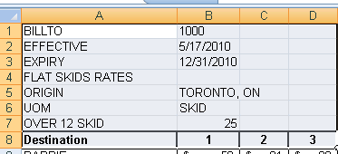
The above example will upload flat skid rates based on the information held in the keywords in cells A1 to A8.
Keyword  (Column A) | Description  (Column B)
Billto | Customer account code from the client file - or the type code if using a type rate.
Effective | The Effective date to assign to the rate. If this doesn't exist, today's date will be assigned as the effective date.
Expiry | The expiry date of the rate. If this doesn't exist no expiry date will be assigned to the rate.
Flat | Indicates if the rate is flat rate per skid. If so each column of rates will contain rates for the number of skids shown in the header.
Origin | Identifies the origin for all of the rates in the spreadsheet.
UOM | Indicates the unit of measure. In this case "skid".
Commodity | Commodity code to use for the rates. If not present the system will use "*".
Origin | The origin location for the rate sheet. eg: Toronto, ON (include both the city and state or province).
Over 12 | The per unit rate above this number of units (eg @25 per skid over 12 skids).
Destination | This keyword denotes the end of the header keywords and the beginning of the rate data. On the same row, the columns "B" to the end should contain the break levels (flat is generally by skid, whereas per hundredweight would show the weight breaks.

Each line after the destination keyword will create a flat rate for the destination identified in column A, for the number of skids described in each of the remaining columns.
NOTE: If the unit of measure is per Hundred-Weight (cwt), then the rates for each break level should be expressed in cents per hundredweight, with no decimals.
* The minimum charge however, in the column headed "MIN", should be expressed in dollars and cents, regardless of the unit of measure chosen.
NOTE: If any of the destination cities do NOT have a state or province code associated with them, the state or province will be assumed to be the same as that of the previous province or state. This includes the state or province identified with the origin keyword. In other words, if no provinces/states are identified in the cities of the destination column, they will be assigned the province/state of the origin city.

LTL Weight Breaks

Additional Keywords relating to CWT Weight breaks
Keyword | Description
Maxflat | This keyword identifies the case where the maximum T/L rate is expressed as a flat rate as opposed to a rate per hundredweight.

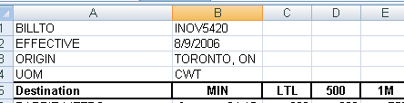
In the above example, the UOM Keyword indicates rates per hundredweight. Valid column headings are:
Column Heading | What it means
MIN | This contains the minimum charge for the origin/destination. Always in dollars and cents, eg. 35.00 and not 3500.  If the unit of measure selected is "CWT", then the rest of the columns should be in cents per hundredweight. EG. 3500, not 35.00.
LTL | In LTL "Parlance" this means any weight up to, but not including, the next column heading. In this example 0-499 lbs.
500 | Weights beginning at 500 up to, but not including the next column. Eg. 500-999 lbs.
1M, 2M, 5M, etc. | In LTL Parlance, the "M" stands for 1,000 so 1M is interpreted as 1000. Use the "M" keyword to denote breaks beginning with this weight (as opposed to ending with the weight).
T/L | Often means the full truck load weight, but is interpreted as anything from 40,000lbs and beyond. NOTE: you should always have a T/L column. This triggers a maximum weight break of up to 99999. If you do not have a T/L column, just repeat values from your last break column in the T/L column, in order to get the correct results.

Service Type "Messenger" Rates
A special keyword - "SVC" or "TMX" - has been introduced to allow for the upload of service type rates where the rows identify a zone location, and the columns identify service types. Keywords for BILLTO, EFFECTIVE, EXPIRY, etc. all behave the same as for the other rate upload types. (Note that the BILLTO Keyword can have a group code as its value.) The "Origin" keyword denotes a zone code. The column headings DR,RS,RG,SD, and ON, denote service type codes for the rate in each corresponding column.
The keyword 'Zone' appearing in column 1 triggers the upload to look for a rate in cells 3 and beyond, assigning the rate to the corresponding service code.
As a convenience, the Zone itself is currently hardcoded from 1-17 in this order: 610,420,410,220,210,120,110,230,310,810,620,240,430,101,250,710,510
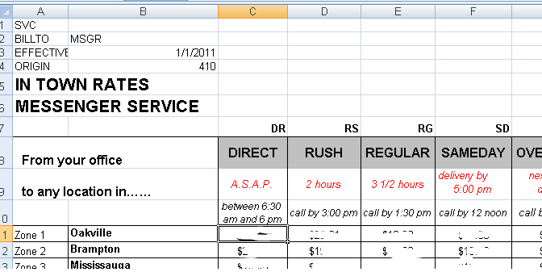

Service Type Skid Rates
These rate types are per skid by zone and by service level, with an additional charge per extra skid for each service level:
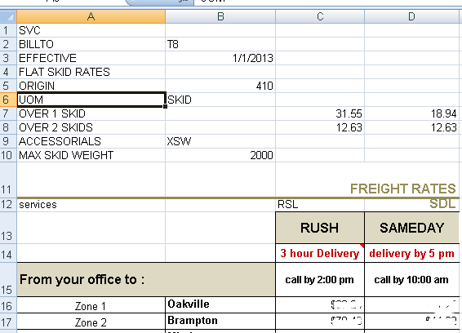

Significant keywords that control the upload are as follows:
Keyword | Meaning
SVC | Indicates service type columns (you can also use "TMX")
Billto | Billto code or rate group (eg.. "T8")
EFFECTIVE | Effective date
EXPIRY | Expiry date, if not rates will remain in effect until a new effective date rate exists
FLAT SKID RATES | Indicates a flat rate per skid
ORIGIN | Origin Zone
UOM | Skid
OVER n SKID(s) | A keyword beginning with "OVER" indicates amounts charged for a number of skids greater than "n". These amounts need to be in the same columns as the service levels to which they apply (See "SERVICES" keyword)
ACCESSORIAL(s) | Indicates any accessorial charge(s) that can be conditionally charged. Specifically used for the extra skid weight accessorial. In the example above, "XSW" is the charge code used for Extra Skid Weight, which is set to 4cents/lb.
MAX | Max Unit Weight - eg when the maximum skid weight before extra weight is charged is 2000, the number 2000 would go in the 2nd column.
SERVICES | Defines the service codes to use for each column amount in the same column as the rates.

Three-tiered skids rates
These rates have 3 tiers based on the average skid rate. These rates are expected to extend from 1 to 20 skids.

Header Keywords
Additional header keywords control how the spreadsheet is processed:
Keyword | Meaning
ORIGIN | Origin Zone *Note the origin can also be changed within the spreadsheet data itself through use of either the keyword " to " between cities, and "between ... and ".
3-Tiered Weights | Identifies that the rates are 3-tiered skid raters
Revision | Updates the revision field of the rate
Reference | Updates the reference field of the rate
Reverse | *Note that the rate's reversibility can be switched by use of the keyword "between ... and" when identifying origin and destination for a specific rate. If the keywords " ... to ..." or "between ... and ..." are not used then the header value of the keyword will be used.

Notes on spreadsheet requirements

- The DESTINATION keyword is still the marker for the beginning of the rate data. However for 3-tiered rates, the actual rate data lines are denoted by the presence of "999" or "000" somewhere in column "A" of the spreadsheet. (In single tiered skid rates the rate data is on each destination line.)
The "999" or "000" corresponds to the description for each tier. (see sample screen-shot below)
- The first time a column A is populated with non-blank data following the keyword "Destination" or at the end of a group of rate data lines emcompassing a rate MUST be the next lane. A lane can be simply a destination, which will then take its origin from the previous lane's origin, or the origin specified on the spreadsheet keywords. If a lane is specified with an origin or destination it must be expressed as "FROM-CITY to TO-CITY, To-CITY" or "between FROM-CITY and TO-CITY". The former identifies a one-way rate. The latter defines a two-way "reversible rate.
- If the Origin ("From City") province differs from the previous origin province, it must be defined with a colon followed by the 2-character province code. Example: TORONTO:ON. (This is because a comma delimiter denotes an additional city in the destination, so a different delimiter for province (or state) must be used.) If the Origin province code is left blank it will default to the previous origin province code.
- If the Destination province is left blank (i.e. not defined via a colon) it will default to the previous destination city province. If it is the very first lane in the spreadsheet it will default to the province of the origin lane.
- Note that multiple destination cities can be defined, in which case the upload will create individual rates for each lane expressed by the comma-delimited list of destinations.
- The entire origin & list of destination cities should be expressed in a single cell, including the "to" or "from...between" keywords.
- The rate data is expected to be in two groups of three-tiers each. Group 1 is for 1-10 skids, and group 2 is for 11-20 skids. If there is no group for skids 11-20, then the end of the rate data MUST be made clear to the upload program by adding the keyword "end" at the end of the first group.
- You cannot mix different types of rates in a spreadsheet.
The screenshot below shows examples of the structur
