In Financial Reporting->Budget you can enter budget information in a number of ways:

1. Upload via a spreadsheet (click on Load XLS button).

- The format is simple. Column "A" is the GL Account, "B" is account name, "C" -to- "N" are the amounts for periods 1 to 12.
- The data load starts at row 7 - so the first 6 rows are for any free form description you may want to have on the spreadsheet.
- The budget will load into the fiscal year set by the window

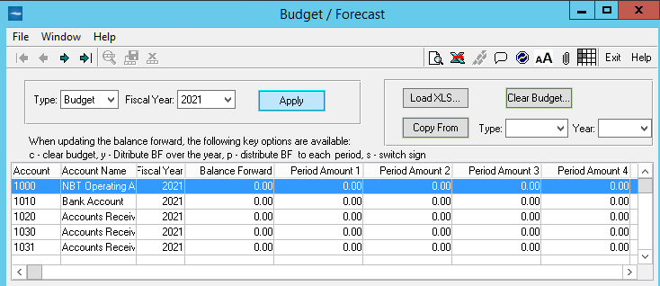

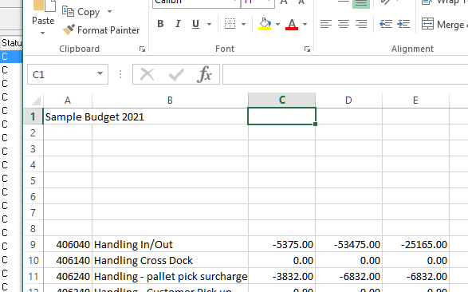
.
2.. You can also copy prior year's actual or budget data into this year's budget.

3. You can enter and edit budget amounts by pressing the grid icon, and use special keys (c,y,p, and s) as described in the window.

