Contents
Tab Security 2
Field Security 4

Tab Security
Tab security in DTMS can only be set as either Accessible or Not Accessible. When a tab is Not Accessible to a user/group than they will not be able to go into the tab although the tab header remains visible on the program screen.
To allocate tab security, you must first add the tab to be secured in the Actions maintenance program if it does not exists already. The action name shall be the name of the tab itself (usually). Suppose if you want to secure the Rates tab as shown below:
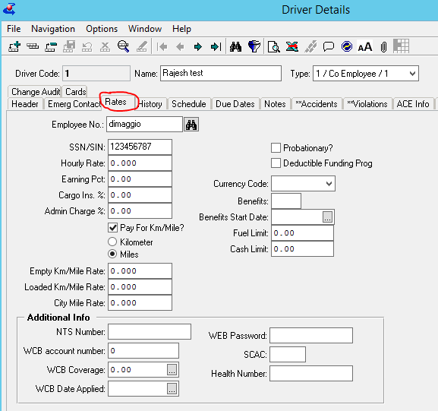
Go to Administration Security Security Maintenance Actions. Create a new action code ‘Rates’ as shown below.
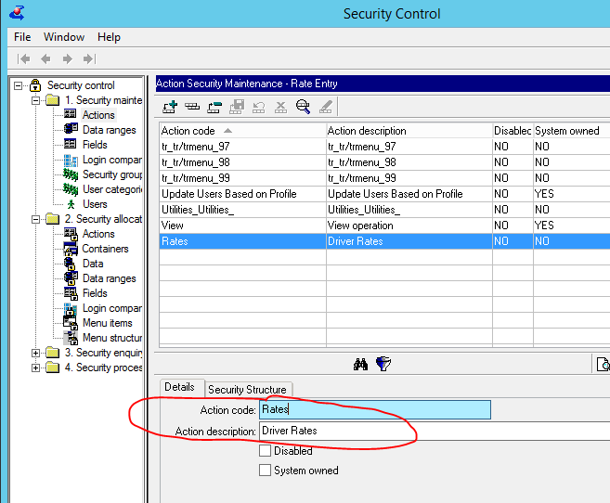
Now go to Administration Security Security Allocation Actions and add the action in the restricted actions section for a user/group as shown below.
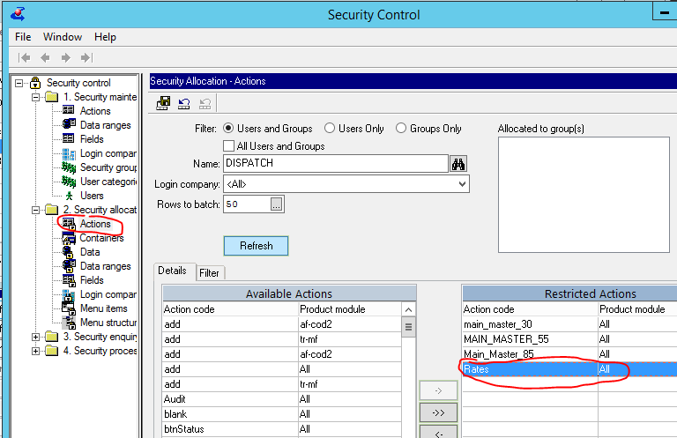

Field Security
Field security in DTMS can be implemented in 3 modes; Full Access, Read-Only and Hidden for a user/group. Implementing field security is little bit difficult than other securities as you need to know the name of the fields that you want to secure. The best way to find a field name is through the Configure Browse option available on Right-Mouse click of every browse.
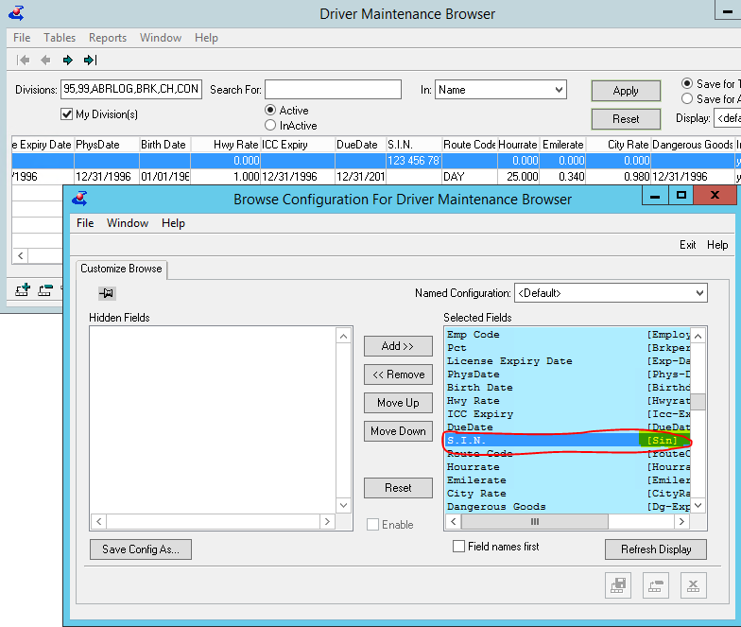
Go to Administration Security Security Maintenance Fields. Create a new field name ‘sin’ as shown below.
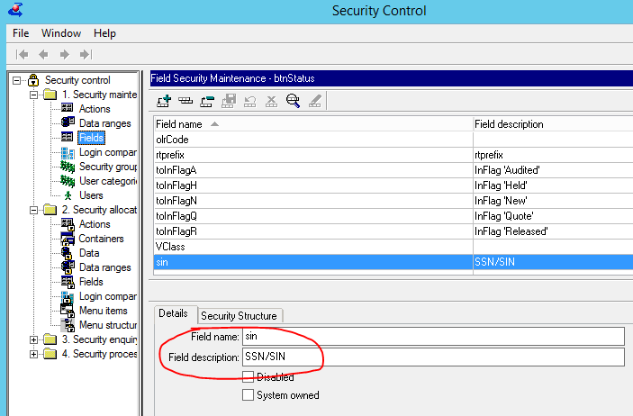
Now go to Administration Security Security Allocation Fields and add the Field in the restricted fields section for a user/group. Then select the security mode you want to set for the particular field and press the Apply button and finally save the security allocation as shown below.
